Operating System Quiz 1

Name: Student ID:
- Consider the following set of processes, with the length of the CPU burst time given in milliseconds:

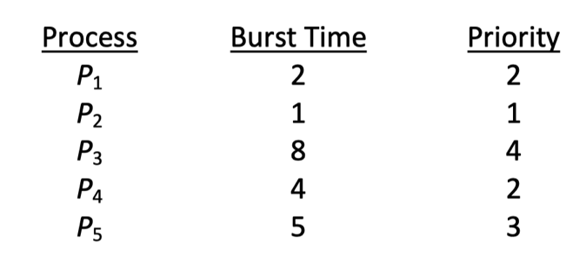
The processes are assumed to have arrived in the order P1 , P2 , P3 , P4 , P5 all at time 0.

- Draw four Gantt charts that illustrate the execution of these processes using the following scheduling algorithms: FCFS, SJF, nonpreemptive priority (a smaller priority number implies a higher priority), and RR (quantum = 1).
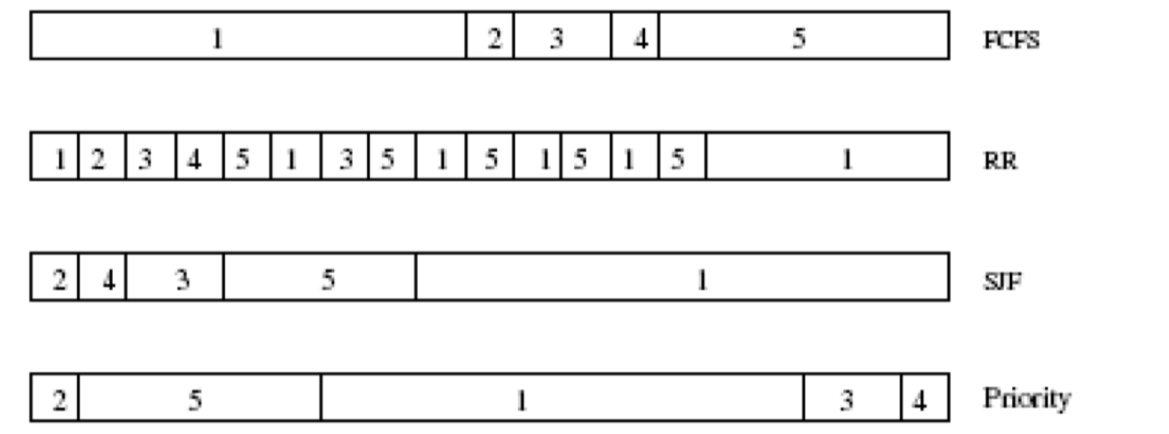

b. What is the turnaround time of each process for each of the scheduling algorithms in part a?

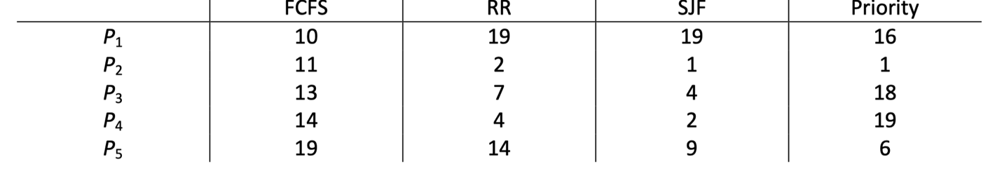

c. What is the waiting time of each process for each of these scheduling algorithms?

d. Which of the algorithms results in the minimum average waiting time (over all processes)?
SJF

- Consider a system running ten I/O-bound tasks and one CPU-bound task. Assume that the I/O-bound tasks issue an I/O operation once for every millisecond of CPU computing and that each I/O operation takes 10 milliseconds to complete. Also assume that the context-switching overhead is 0.1 millisecond and that all processes are long-running tasks. Describe the CPU utilization for a round-robin scheduler when:
- The time quantum is 1 millisecond
The time quantum is 1millisecond: Irrespective of which process is scheduled, the scheduler incurs a 0.1 millisecond context-switching cost for every context-switch. This results in a CPU utilization of 1/1.1 * 100 = 91%.

b. The time quantum is 10 milliseconds
The time quantum is 10 milliseconds: The I/O-bound tasks incur a context switch after using up only 1 millisecond of the time quantum. The time required to cycle through all the processes is therefore 10*1.1 + 10.1 (as each I/O-bound task executes for 1 millisecond and then incur the context switch task, whereas the CPU-bound task executes for 10 milliseconds before incurring a context switch). The CPU utilization is therefore 20/21.1 * 100 = 94%.

- On some computer, the clock interrupt handler needs 2 msec (including context switch
overhead) per clock tick to execute, and the clock runs at 75 Hz. What fraction of the CPU time is devoted to the clock?
- 10%
- 15%
- 20%
- 25%
In “Multilevel Queue Fixed priority” scheduling algorithm, current statistics of processes in each queue and their scheduling algorithms are shown below. In this algorithm, processes in the “first foreground” are scheduled first, then the “second foreground” and the “background”. In each queue, we use different scheduling technique, e.g., in the “first foreground”, RR is applied. Please answer question 4 and 5.

Process Burst time Arriving time Algorithm
1st Foreground P1 50 0.0 RR interval:20
P2 15 30.0 (RR is non-preemptive)
2nd Foreground P4 40 0.0 SJF Preemptive
P5 10 120.0
Background P6 30 60.0 FCFS
P7 20 130.0

- What is the average waiting time?
A. 22 B. 52 C. 96 D. 43
- What is the average turnaround time?
A. 140 B. 114 C. 96 D. 81

Suppose we have four resources, RA, RB, RC and RD. Given below current matrix, available vector and maximal requirement matrix, please answer question 6 to 7.

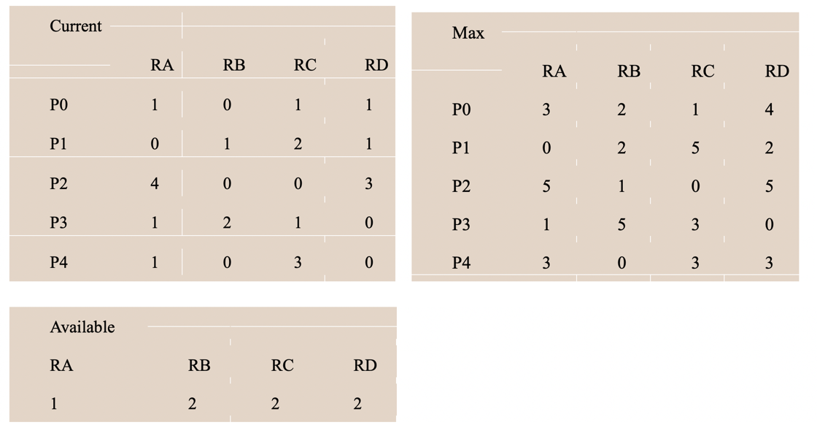
- What is the current state of existing system?
A. deadlock B. unsafe C. safe D. not sure
- Can a request of one instance of RA by Process P0 be granted safely according to Banker’s algorithm?
A. can, but unsafe B. cannot, deadlock C. can, safe D. not sure

- In Many-to-One thread model, What would happen if a thread in a multithreaded process makes a blocking system call?
A. the other threads of the process would continue to run
B. the entire process would get blocked
C. the blocking thread will get killed
D. the blocking thread will never get to run again

- There are N processes which share M mutual exclusive resources, each process can hold W resources at most. Which of the following condition may cause a deadlock?
A. M=2, N=1, W=2 B. M=2, N=2, W=1 C. M=4, N=3, W=2 D. M=4, N=2, W=3

- Consider the following resource trajectory graph for a system with two processes (P1 and P2) and two resources (R1 and R2). The x-axis and y-axis represent the time when P1 and P2 will request their resource respectively. Which of the following statements is correct?
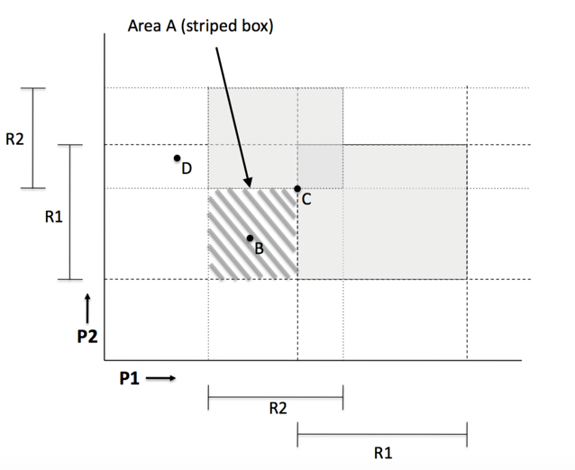
A. The system is deadlocked at point B.
B. The system is safe at point B.
C. The system is safe at point D.
D. Point C represents a transition between safe state and deadlock.

- What is the purpose of system calls?
A. System calls allow user-level processes to gain resources from the operating system.
B. System calls are the standard interface between a user process and a kernel process.
C. System calls allow user-level processes to request services of the operating system.
D. There is no real purpose to system calls.

- What information is stored in a thread control block (TCB)?
A. List of open files.
B. Stack pointer.
C. Memory map.
D. Thread owner ID

- A computer system has a device with n mutually exclusive instances. Three concurrent processes require 3,4 and 5 instances. To ensure deadlock not to occur, what is the minimum number n?
- 9 B. 10 C. 11 D. 12

- Suppose 4 jobs, each of which having a burst time of 2 minutes, are submitted to a system at almost the same time. If the system uses the FCFS scheduling algorithm, what is the average turnaround time of these 4 jobs? _________
A. 3 minute B. 4 minutes C. 5 minutes D. 6 minutes

- Four processes R1, R2, W1, and W2 share a buffer space named B. R1 reads a number from the keyboard and saves it into B, so that the saved number is only consumed by W1, which prints the number to the screen. R2 reads a character from a mouse and also saves the character into B, so that only W2 can print the character to a printer. Please write the synchronization code for the four processes so that no race condition may arise among them. Define semaphores if necessary.

